TASK 2: CORE SECURITY CONCEPTS
Name: Yakshitha Sri N D
Register no: RA2611003020166
Task 2 — Beginner-Friendly Cybersecurity Fundamentals
Cybersecurity protects information and systems by making sure data stays private, accurate, accessible, and properly controlled. The five concepts below are explained using concrete real-world situations.
1. Confidentiality
Meaning: Confidentiality means only people who are authorized to see certain information can actually access it. Everyone else is locked out, even if they work at the same company or use the same system.
Real-World Scenario: A hospital employee logs into the patient records system and is able to see medical files that are not assigned to them. If the system does not restrict access based on the employee's role, confidentiality is violated even though nothing was stolen in the traditional sense—the data was simply visible to someone who should not have been able to see it. Hospitals use Role-Based Access Control (RBAC), so a nurse can see the patients assigned to them rather than the entire hospital database.

Original realistic visual illustration — Confidentiality
Why it matters: It protects personal, sensitive, and private information from being seen by unauthorized people.
2. Integrity
Meaning: Integrity means data stays accurate and unaltered unless it is changed by someone who is authorized to change it. If data is tampered with—even a single value—integrity has been broken.
Real-World Scenario: A student hacks into their school's grading portal and changes a failing grade to an A. The grade is no longer trustworthy, even though it is still available to view and was not shared with anyone else. The integrity of the record was violated because the value was changed without authorization. Real systems can use checksums, version history, and audit logs to detect and trace unauthorized changes.
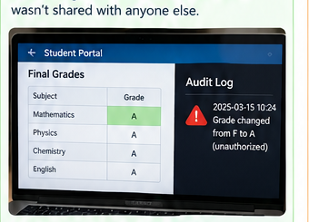
Original realistic visual illustration — Integrity
Why it matters: It helps people trust that stored information is correct and has not been secretly changed.
3. Availability
Meaning: Availability means systems and data are accessible to authorized users whenever they need them. If a system goes down, becomes overloaded, or is deliberately taken offline, availability is violated—even if the underlying data is safe and unchanged.
Real-World Scenario: An attacker launches a DDoS (Distributed Denial of Service) attack against an online banking website, flooding its servers with fake traffic until real customers cannot log in to check their balance or pay a bill. Nothing was stolen and nothing was changed, but legitimate users cannot reach the service. Companies use load balancers, traffic filtering, and DDoS protection to keep services reachable.
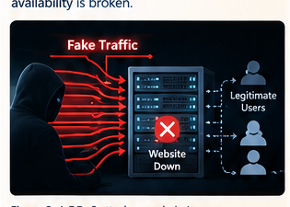
Original realistic visual illustration — Availability
Why it matters: It keeps important services and information accessible when authorized users need them.
4. Authentication vs. Authorization
Meaning: Authentication is the process of proving who you are—for example, by entering a correct username and password or scanning a fingerprint. Authorization is what you are allowed to do after your identity has been confirmed.
Real-World Scenario: An employee logs into their company's shared drive using their correct username and password. That is authentication: the system confirms who they are. When they try to open the 'HR Salaries' folder, which they are not permitted to view, the system blocks them. That is authorization working correctly. Being authenticated does not automatically mean you are allowed to access everything.
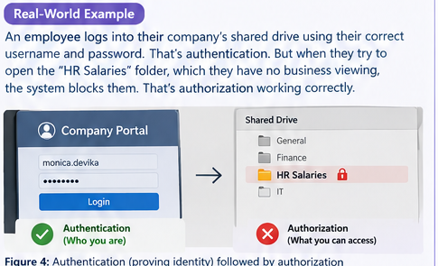
Original realistic visual illustration — Authentication vs. Authorization
Why it matters: It ensures the right person gets the right level of access—not simply access to everything.
5. Encryption vs. Hashing
Meaning: Encryption scrambles data so it can be unscrambled later using a key. It is reversible. Hashing converts data into a fixed-length scrambled value that is not meant to be reversed; it is one-way.
Real-World Scenario: When you send a message on WhatsApp, the message is encrypted so it can be protected during communication and then decrypted by the intended recipient. Passwords are handled differently: a website can store a hash of a password instead of the original password. During login, the entered password is hashed and compared with the stored value. The site does not need to recover the original password from the hash.
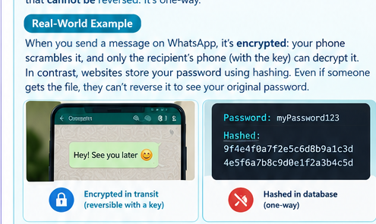
Original realistic visual illustration — Encryption vs. Hashing
Why it matters: Encryption protects data during transfer or storage, while hashing is commonly used to protect passwords and verify data without storing the original value.
Conclusion
The CIA Triad—Confidentiality, Integrity, and Availability—forms a basic foundation of cybersecurity. Authentication and authorization control identity and permissions, while encryption and hashing protect information in different ways. Together, these concepts help organizations keep systems trustworthy and secure.

